**IPL Data Analysis Using Python and Power BI**

*Project report submitted in partial fulfillment of the requirement for the degree of*

**BACHELOR OF TECHNOLOGY**

**IN**

**COMPUTER SCIENCE ENGINEERING**

*by*

**Yogesh Kapoor(17212610080) Shubham Saklani(17212610067)**

**Ayush (17212610026)**

**UNDER THE GUIDANCE OF**

Dr. Balvir Singh Thakur



## UNIVERSITY INSTITUTE OF TECHNOLOGY, HIMACHAL PRADESH UNIVERSITY, SHIMLA

### June, 2025

Copyright © UIT - HPU Shimla, INDIA, 2025

# 

# 

# 

CERTIFICATE OF DECLARATION

We hereby declare that the work reported in the B.Tech. Project Report entitled **“IPL Data Analysis Using Python and Power BI”** submitted at the **University Institute of Technology, Himachal Pradesh University, Shimla** is an authentic record of our work carried out under the supervision of **Dr Balvir Singh Thakur**, Dept. of Computer Science Engineering. We have not submitted this work elsewhere for any other degree or diploma.

|  |  |  |
| --- | --- | --- |
| **Yogesh Kapoor** | **Shubham Saklani** | **Ayush** |
| 17212610080 | 17212610067 | 17212610026 |

This is to certify that the above statement made by the candidates is correct to the best of our knowledge

# ACKNOWLEDGEMENT

First and foremost, we extend our deepest appreciation to **Dr. Balvir Singh Thakur** whose valuable guidance, encouragement, and expertise have been instrumental in the successful completion of this project. Their insights and constructive feedback have helped me refine my work and deepen my understanding of **Data Analysis.**

We are also grateful to my institution, **University Institute of Technology, Summer Hill Shimla**, and the **Computer Science Department** for providing the necessary resources, infrastructure, and a conducive learning environment.

A special thanks to our friends and peers for their continuous motivation, discussions, and assistance in troubleshooting technical challenges. Their support has played a significant role in refining the implementation and improving the project's overall quality.

Lastly, we extend our heartfelt appreciation to our family for their constant encouragement, patience, and belief in our capabilities. Their unwavering support has been our biggest source of strength.

This project has been a great learning experience, and We are thankful for all the knowledge and skills we have gained during this journey.

# ABSTRACT

The IPL Delivery Data Analysis project aims to extract meaningful insights from historical Indian Premier League (IPL) datasets by leveraging Python for data preprocessing and analysis, and Power BI for dynamic visualizations. The project utilizes two main datasets: matches.csv containing match-level data and deliveries.csv with ball-by-ball delivery records.

Using powerful Python libraries such as Pandas, Matplotlib, Seaborn, and Plotly, we performed extensive exploratory data analysis (EDA) to identify patterns related to player performance, team success rates, venue statistics, and toss impacts. Key observations include most frequent match winners, top-performing batsmen and bowlers, and the influence of toss decisions on match outcomes.

To enhance data interpretability and user interaction, we created interactive dashboards in Power BI showcasing KPIs, charts, and filters that help navigate complex cricket data effortlessly. These visual tools aid stakeholders in understanding trends, player consistency, and team strategies.

This project demonstrates the practical application of data science and visualization tools in the domain of sports analytics. The insights gained can support teams, coaches, analysts, and sponsors in making data-driven decisions, thereby transforming raw IPL data into valuable strategic knowledge.

# TABLE OF CONTENT

1. **Introduction**
2. **Objectives**  
    2.1 Data Collection and Understanding  
    2.2 Data Cleaning and Preprocessing  
    2.3 Exploratory Data Analysis (EDA)  
    2.4 Data Visualization using Power BI  
    2.5 Performance Comparison of Players and Teams  
    2.6 Decision-Making Support for Stakeholders
3. **Literature Review**  
    3.1 Overview of IPL Analytics  
    3.2 Previous Research Studies  
    3.3 Gaps in Existing Work
4. **Tools and Technologies Used**  
    4.1 Python Programming Language  
    4.2 Python Libraries  
    4.3 Power BI  
    4.4 Jupyter Notebook
5. **Data Collection and Dataset Description**
6. **Data Cleaning and Preprocessing**
7. **Exploratory Data Analysis (EDA)**
8. **Visualization in Power BI**
9. **Dashboard and Key Insights**
10. Code Snippets
11. Web-Based Match Prediction Module
12. **Conclusion**
13. **References**
14. **Appendix**

# INTRODUCTION

Cricket is more than just a sport in India; it is an emotion that unites millions of people. The advent of the Indian Premier League (IPL) in 2008 revolutionized cricket by introducing a fast-paced, commercially rich, and globally recognized T20 format. Each IPL season brings with it hundreds of matches, thousands of deliveries, and immense opportunities to analyze the game at a granular level. From fans and broadcasters to team analysts and strategists, IPL data has become an integral part of how the game is viewed and understood.

This project, titled “IPL Delivery Data Analysis using Python and Power BI”, is aimed at analyzing ball-by-ball data from various IPL seasons to uncover hidden patterns, trends, and insights. It leverages the power of data analytics to transform raw delivery-level cricket data into meaningful, actionable intelligence.

The dataset used in this project includes delivery-level records such as match ID, batting team, bowling team, over and ball number, batsman and bowler name, runs scored, extras, wicket details, and more. Each record represents one ball bowled in the IPL, making the dataset both rich and complex.

To handle and analyze this data efficiently, we use Python, one of the most widely used programming languages in data science. Python’s libraries like Pandas are used for data manipulation and cleaning, NumPy for numerical computations, Matplotlib and Seaborn for visual exploration of trends. These tools help us perform Exploratory Data Analysis (EDA), enabling us to answer key questions like:

* Which batsman has the highest strike rate?
* Who are the most economical bowlers?
* Which team performs best in powerplay or death overs?
* What is the impact of toss on match outcome?

After processing and analyzing the dataset in Python, the insights are visualized using Power BI, a powerful data visualization and business intelligence tool. Power BI enables the creation of interactive dashboards, where users can filter data based on season, team, venue, player, and other dimensions. The dashboard includes visuals such as:

* Top run scorers and wicket takers
* Venue-wise performance analysis
* Toss decision impact
* Player comparisons based on roles (batsman, bowler, all-rounder)
* Over-by-over scoring pattern

This combination of Python for data processing and Power BI for dashboarding creates an end-to-end data analytics pipeline. The project demonstrates how data science techniques can be applied to sports data to derive insights that are not easily visible through traditional scorecards.

The main motivation behind this project is to showcase real-world application of data analysis using tools and techniques commonly used in the industry. IPL is chosen as the subject due to its vast and diverse dataset, global popularity, and potential for uncovering interesting and impactful stories through data.

Overall, this project highlights how delivery-level data, when cleaned, analyzed, and visualized properly, can not only help cricket fans understand the game better but also aid professional analysts, coaches, and teams in decision-making. With the ever-growing role of analytics in sports, this project aligns well with modern trends and provides a strong foundation in practical data analysis.

# OBJECTIVE

The primary objective of the **IPL Delivery Data Analysis** project is to extract meaningful insights from IPL’s ball-by-ball data using modern data analysis and visualization tools. This project aims to demonstrate the real-world application of data analytics in sports, particularly cricket, by processing and interpreting large datasets effectively. The project is designed with the following specific objectives:

### **2.1 Data Collection and Understanding**

The first step of the project involves acquiring high-quality delivery-level IPL data, understanding the data schema, and interpreting the structure of information such as batsman, bowler, over, ball, runs, extras, wickets, etc. This objective ensures that we have a solid understanding of what the dataset contains and how it can be leveraged for meaningful analysis.

### **2.2 Data Cleaning and Preprocessing**

Before any analysis, the raw dataset is cleaned and transformed using **Python libraries** such as **Pandas and NumPy**. This step includes:

* Handling missing values
* Removing duplicates
* Standardizing team and player names
* Converting data types
* Filtering useful columns

The goal is to ensure that the dataset is analysis-ready and consistent for visualization and interpretation.

### **2.3 Exploratory Data Analysis (EDA)**

One of the major objectives of the project is to perform in-depth exploratory data analysis using Python. This includes:

* Identifying top-performing batsmen and bowlers
* Analyzing strike rate, economy rate, boundary frequencies
* Understanding team performance trends over seasons
* Match-winning factors (e.g., toss decision, venue advantage)
* Over-wise run distributions (Powerplay, middle overs, death overs)

EDA helps uncover hidden patterns and trends that are not obvious in traditional scorecards.

### **2.4 Data Visualization using Power BI**

Another important objective is to transform the statistical findings into **interactive dashboards** using **Power BI**. This includes:

* Designing visualizations such as bar charts, pie charts, line graphs, and heat maps
* Enabling filters for season, team, venue, and players
* Creating report pages that summarize batting, bowling, and match-level insights
* Publishing a user-friendly dashboard for non-technical users

Power BI helps make the analysis more accessible and understandable to a broader audience.

### **2.5 Performance Comparison of Players and Teams**

The project aims to enable detailed comparison between players and teams based on their historical performance. For example:

* Comparing top 5 batsmen across different seasons
* Analyzing bowler economy under different match conditions
* Finding best partnerships or highest scoring overs
* Identifying match-winning all-rounders

Such comparisons support more strategic conclusions and storytelling with data.

### **2.6 Decision-Making Support for Stakeholders**

A key objective of this project is to demonstrate how data analytics can help different stakeholders such as:

* **Team analysts**: For player selection and match planning
* **Commentators and broadcasters**: For data-driven insights
* **Fans and fantasy league players**: For better predictions and engagement

The project serves as a model of how analytics can be used to support decision-making in sports.

### **2.7 Building an End-to-End Analytics Pipeline**

From raw CSV files to a clean dataset, from Jupyter Notebook analysis to a Power BI dashboard — the project shows how to:

* Collect
* Clean
* Analyze
* Visualize
* Present

The objective is to complete the **end-to-end data analytics workflow** that mirrors real-world industry projects.

### **2.8 Skill Development and Practical Exposure**

This project also focuses on applying the theoretical knowledge of data analytics in a practical setting. It helps in strengthening skills in:

* Python programming
* Data wrangling
* Statistical analysis
* Data visualization tools like Power BI
* Analytical thinking and storytelling with data

## Literature Review

### 3.1 Overview of IPL Analytics

In the last decade, the field of sports analytics has experienced exponential growth due to the increasing availability of detailed data and advancements in computational tools. Cricket, and particularly the Indian Premier League (IPL), stands out as a major contributor to this trend. The IPL, being one of the most popular and commercially successful T20 leagues globally, generates vast amounts of ball-by-ball data, capturing every single delivery bowled in matches across seasons.

This granular data enables analysts to delve deeper than traditional statistics, providing insights not only on overall match results but also on individual player performances, team strategies, and situational factors such as powerplay efficiency or death over performance. The ability to analyze such detailed datasets has revolutionized how teams prepare, how commentators narrate the game, and how fans engage with the sport.

Furthermore, the rise of data science tools such as Python, along with powerful visualization platforms like Power BI, has made it possible to handle complex datasets, clean and preprocess the data efficiently, and build interactive dashboards that present data-driven stories in an easily understandable format. These innovations have democratized sports analytics, allowing a wide range of stakeholders, from analysts to fans, to benefit from data insights.

### 3.2 Previous Research Studies

The academic and professional community has shown considerable interest in cricket analytics, leading to a range of studies and projects focused on different aspects of the game:

* **Performance Prediction Models:** In 2017, a notable study titled "Cricket Performance Analysis using Data Mining" applied machine learning classification algorithms such as decision trees to predict match outcomes based on features like total runs, wickets, and venue conditions. This approach highlighted the potential of data mining in sports but was limited by the lack of ball-by-ball data, restricting the granularity of analysis to overall match summaries.
* **Visualization-Focused Studies:** The "International Journal of Computer Applications" published a study in 2019 titled “IPL Data Visualization using Tableau”, which concentrated on the graphical representation of IPL data through interactive dashboards. This research offered useful summaries, such as lists of top run-scorers and winning teams, enhancing the interpretability of statistics for non-technical users. However, it lacked backend data processing and detailed statistical analysis, which are crucial for uncovering deeper insights.
* **Kaggle Competitions and Public Datasets:** Platforms like Kaggle have hosted IPL-related data science competitions where participants analyzed player performances and match results using various algorithms like logistic regression, random forests, and gradient boosting. While these projects often demonstrated strong coding skills and statistical analysis, most remained confined to static Jupyter notebooks without integrating visualization tools or deploying interactive dashboards for broader accessibility.
* **Player and Match-Level Analytics:** Some research has focused on individual player metrics such as strike rates, economy rates, and batting or bowling averages. Other works examined the impact of external factors such as toss decisions, venue, and match phase (powerplay, middle overs, death overs) on outcomes. Yet, many studies have not combined these aspects into a unified, user-friendly analytics pipeline.

### 3.3 Gaps in Existing Work

Despite the significant contributions from previous studies, certain gaps remain in the realm of IPL analytics:

* **Lack of End-to-End Integration:** Most existing works focus on either data preprocessing and analysis or visualization separately, rather than integrating all phases into a seamless pipeline. This fragmentation limits the practical usability of these insights in real-world decision-making contexts.
* **Limited Interactivity in Visualization:** The majority of projects present static charts or reports that do not allow users to filter data dynamically by season, team, venue, or player. Such interactivity is essential to cater to different stakeholder needs, such as analysts, broadcasters, coaches, and fans.
* **Underutilization of Delivery-Level Data:** While ball-by-ball data contains rich information, it is often underused or only partially analyzed. Detailed delivery-level analysis can reveal patterns related to specific game situations, player form, or tactical decisions that are not visible in aggregated match summaries.
* **Scalability and Real-Time Insights:** Many research projects do not address scalability issues or the potential for real-time data updating and dashboard refreshing, which are important for modern sports analytics applications.

## Tools and Technologies Used

The success of any data analytics project relies heavily on the selection of the right tools and technologies. In this project, titled “IPL Delivery-Level Data Analysis using Python and Power BI”*,* a combination of programming, data processing, and visualization tools has been employed to extract meaningful insights from complex cricket data. Each tool has played a significant role in transforming raw delivery-level records into interactive and insightful visual dashboards.

### 4.1 Overview

This project required the use of both backend analytical tools and frontend visualization platforms. Python was chosen for its robust data analysis capabilities, while Power BI was selected for its ability to present data in a visually appealing and user-interactive manner. Together, they form a complete end-to-end analytics pipeline — from data acquisition to insight generation and presentation.

### 4.2 Python Programming Language

Python served as the primary programming language for this project due to its readability, flexibility, and the vast ecosystem of data science libraries. Python is extensively used in the industry for data manipulation, statistical modeling, and automation. In this project, Python was used to:

* Read and interpret raw delivery-level IPL datasets (in CSV format)
* Clean and preprocess data to handle inconsistencies
* Conduct statistical and trend-based analysis on batsmen, bowlers, teams, and match outcomes
* Automate the filtering and transformation of large datasets into analysis-ready formats

Python also facilitated the development of reusable scripts, ensuring that future datasets can be processed similarly with minimal effort.

### 4.3 Data Analysis Libraries

Several specialized Python libraries were used in conjunction with one another for efficient data handling and visualization.

* **Pandas:**  
  Pandas is a foundational library for data analysis in Python. It provides data structures such as Series and DataFrames, which are highly efficient for structured data. Pandas was used for:
  + Importing datasets
  + Filtering relevant columns
  + Handling missing values
  + Standardizing team/player names
  + Grouping and aggregating data for analysis
* **NumPy:**  
  NumPy supports high-performance array operations and mathematical functions. It was used for:
  + Efficient computation of strike rates, economy rates, averages, etc.
  + Performing statistical calculations and numerical transformations
* **Matplotlib and Seaborn:**  
  These libraries were used for creating visualizations during Exploratory Data Analysis (EDA).
  + **Matplotlib** enabled the creation of basic bar charts, line graphs, and scatter plots.
  + **Seaborn** offered enhanced capabilities such as heatmaps, distribution plots, and categorical comparisons, making data trends and correlations visually easy to interpret.

### 4.4 Power BI

Power BI is a cloud-based business intelligence and data visualization tool developed by Microsoft. It is designed to convert raw data into interactive dashboards and reports with real-time filtering capabilities.

In this project, Power BI played a crucial role in:

* Importing cleaned datasets exported from Python
* Designing custom visuals like bar charts, pie charts, slicers, and line graphs
* Enabling multi-dimensional filtering (by team, player, season, venue, etc.)
* Creating dashboards that support comparative and historical analysis of IPL players and teams
* Publishing reports that can be shared with users who do not require programming knowledge

Power BI’s built-in DAX (Data Analysis Expressions) language allowed additional calculated fields, making the analysis richer and more dynamic.

# Data Collection and Dataset Description

Data collection is the foundation of any data-driven project. In this project, we aimed to collect and analyze delivery-level data from the Indian Premier League (IPL), which includes detailed information about every ball bowled in the tournament. The dataset forms the backbone of the analysis and visualization phases and must be accurate, complete, and structured.

### 5.1 Data Source

The dataset used in this project was sourced from publicly available repositories such as Kaggle and open cricket data archives. These sources provide comprehensive ball-by-ball datasets of IPL matches, typically in CSV format. Each row in the dataset represents a single delivery and contains attributes related to match context, player actions, and outcomes.

Examples of reliable data sources:

* [Kaggle IPL Datasets](https://www.kaggle.com/)
* [Cricsheet.org](https://cricsheet.org/)
* [ESPNcricinfo – for manual verification](https://www.espncricinfo.com/)

### 5.2 Structure of the Dataset

The dataset consists of thousands of rows, each representing a single delivery (ball) bowled in an IPL match, and contains multiple features including:

* match_id – Unique identifier for each match
* inning – First or second inning of the match
* over **&** ball – Specific delivery within the over
* batting_team **/** bowling_team – Teams involved in that delivery
* batsman **&** bowler – Players involved in the delivery
* runs_batsman **/** runs_total – Runs scored off the bat and total runs (including extras)
* extras_type – Type of extra (wide, no-ball, bye, etc.)
* player_dismissed **&** dismissal_kind – Wicket-related information
* fielder – Fielder involved in dismissal (if any)

This granularity allows analysts to slice the data by players, overs, innings, match situations, and even specific patterns like performance under pressure or during powerplays.

### 5.3 Data Volume and Time Span

The dataset spans multiple IPL seasons (e.g., from 2008 to 2023), covering **hundreds of matches** and **over 150,000 deliveries**. This vast volume provides significant scope for deep analysis, pattern recognition, and performance comparisons across players, teams, and seasons.

### 5.4 Data Integrity and Limitations

While the dataset is detailed and rich, some challenges were encountered during data collection:

* Inconsistent naming conventions (e.g., “Rajasthan Royals” vs “RR”)
* Missing or null values for older seasons or specific deliveries
* Minor discrepancies in player spellings or roles

These issues were addressed during the data cleaning phase, ensuring the final dataset used for analysis was consistent, complete, and ready for visualization.

# Data Cleaning and PreProcessing

Using df.isnull().sum(), we identified the columns that had missing values. While most essential columns were complete, a few columns like fielder, dismissal_kind, and player_dismissed had missing entries which were expected due to the nature of the game (not every ball results in a dismissal).  
In such cases, missing values were either:

* **Filled with 'NA' or appropriate placeholders** if needed for categorical processing.
* **Left as-is** when missingness was meaningful (e.g., no dismissal means dismissal_kind remains blank).

### **6.2 Removing Duplicate Entries**

Duplicate deliveries would corrupt analysis like total runs, averages, or over-based statistics. We used:

df.drop_duplicates(inplace=True)

to remove any repeated rows in the dataset. This ensured every ball was counted only once.

### **6.3 Standardizing Team and Player Names**

In different seasons, some teams changed names (e.g., Delhi Daredevils → Delhi Capitals). Using replace() function, we standardized team and player names to avoid misgrouping during analysis.df['batting_team'] = df['batting_team'].replace('Delhi Daredevils', 'Delhi Capitals')

### **6.4 Converting Data Types**

Data types were optimized for better performance:

* match_id converted to str to avoid unintended numerical operations.
* over, ball, and inning converted to int for plotting and grouping.
* Dates were parsed properly if needed using pd.to_datetime().

### **6.5 Dropping Irrelevant Columns**

Columns such as umpire1, umpire2, and some unnamed columns were removed to keep the dataset focused. These fields were not directly useful for delivery-level performance analysis and made the data heavier than necessary.

### **6.6 Verifying the Cleaned Dataset**

After cleaning, the .info() and .head() functions were used to verify that the dataset:

* Had correct data types
* Contained no duplicates
* Was free from major missing values
* Had a consistent structure across seasons

This finalized dataset was now ready for detailed **Exploratory Data Analysis (EDA)** and visualization.

## 

## Exploratory Data Analysis (EDA)

Exploratory Data Analysis (EDA) is a crucial phase in any data analysis project. In this project, EDA was conducted using Python libraries like Pandas, Matplotlib, Seaborn, and Plotly to uncover hidden trends and performance metrics in IPL data. It helped in transforming raw delivery-level data into comprehensible insights.

### Key EDA Insights and Visualizations:

### **7.1 Matches Played Per Season**

This visualization shows the number of IPL matches conducted in each season.

python

CopyEdit

plt.figure(figsize=(20,7))

sns.countplot(df_matches['season'])

plt.title('Matches Played Per Season')

plt.show()

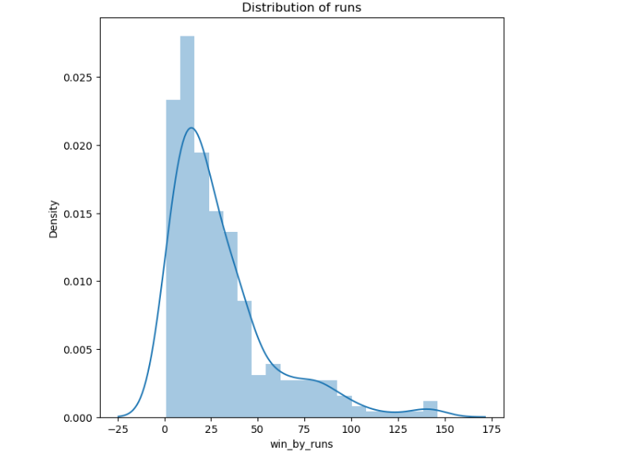

# 7.2 Number of Matches played by each team

# This output shows how many matches each team has participated in across all IPL seasons. It gives a comparative view of team participation.

# display(df_matches["team1"].value_counts().to_frame().rename({'team1':'NumOfMatches'},axis=1).style.background_gradient('RdBu'))

# 

# **7.3** Who Is The Batsman Of Hitting Highest Sixes.

# This visualization highlights the top 10 batsmen who have hit the most sixes in IPL history. It reflects aggressive batting performance.

# six = df_deliveries[df_deliveries['batsman_runs']==6]

# batsman_with_highsixes = six.groupby('batsman').count()['batsman_runs'].sort_values(ascending=False).head(10)

# batsman_with_highsixes

# plt.figure(figsize=(12,6))

# sns.barplot(data=df_deliveries,x=batsman_with_highsixes.index,y=batsman_with_highsixes)

# 

# **7.4 T**he top 5 players who got the highest number of man of the matches awards.

# This bar chart displays the top 5 players who have received the highest number of 'Player of the Match' awards across IPL seasons.

# df_matches['player_of_match'].value_counts()[0:5]

# pe.bar(df_matches['player_of_match'].value_counts()[0:5])

# 

# **7.5** Who Is The Top Wicket Taker.

# This bar graph showcases the bowlers with the highest number of wickets in IPL. It provides insight into consistent bowling performance.

# df_deliveries.groupby('bowler')['player_dismissed'].count().sort_values(ascending=False).head(10)

# plt.figure(figsize=(12,6))

# df_deliveries.groupby('bowler')['player_dismissed'].count().sort_values(ascending=False).head(10).plot(kind='bar',color='blue')

# plt.title('Top Wicket Taker Of IPL')

# plt.xlabel('Bolwer')

# plt.ylabel('Total Wicket Taken')

# plt.show()

# 

**Power BI Dashboard Visualization and Insights**

This section details the process of creating interactive and insightful visualizations using Microsoft Power BI. Following the comprehensive data cleaning and exploratory data analysis (EDA) performed in Python, Power BI serves as the primary tool for translating complex datasets into easily understandable visual narratives. The objective is to provide a dynamic platform for stakeholders to explore IPL performance metrics, identify trends, and support data-driven decision-making.

### 8.1 Connecting Data Sources

The first step in Power BI involved establishing a connection to the cleaned and preprocessed data. This typically includes importing the matches.csv and deliveries.csv datasets (or their refined versions) that were prepared during the data cleaning and preprocessing phases. Power BI's Get Data feature was utilized to connect to these CSV files, ensuring that the latest cleaned data was accessible for visualization.

### 8.2 Data Modeling and Relationships

To enable comprehensive analysis across both datasets, a robust data model was established within Power BI. Relationships were created between the matches and deliveries tables based on common keys (e.g., match_id). This crucial step allows for seamless integration of data, enabling the creation of visualizations that combine information from both datasets, such as linking match outcomes to individual ball-by-ball performance. Measures and calculated columns were also defined to derive key performance indicators (KPIs) relevant to IPL analytics, such as strike rates, economy rates, total runs, and wickets.

### 8.3 Designing Interactive Visualizations

A variety of visualization types were employed in Power BI to present different facets of the IPL data. Each visualization was carefully chosen to best convey the underlying patterns and insights. The key visualizations developed include:

* Bar Charts: Used to display categorical data such as the number of matches won by each team, top run-scorers, or top wicket-takers. These charts effectively compare performance metrics across different entities.
* Line Charts: Ideal for showing trends over time, such as team performance across different IPL seasons, or how average scores have changed over the years.
* Pie Charts/Donut Charts: Employed for illustrating proportions, for example, the percentage of matches won batting first versus chasing, or the distribution of toss decisions.
* Scatter Plots: Useful for identifying correlations between two numerical variables, such as runs scored versus balls faced, or team batting averages against bowling economy rates.
* Maps (if city data is sufficient): If city data is detailed enough, maps could be used to visualize match distribution across different venues or highlight city-specific performance.
* Tables and Matrices: Essential for presenting detailed, tabular data that might not be suitable for graphical representation, allowing users to drill down into specific records.
* Cards: Used to highlight single, important KPIs, such as the overall highest score, or the total number of matches played.

Emphasis was placed on designing visuals that are intuitive, easy to interpret, and aesthetically pleasing, adhering to best practices in data visualization. Interactive elements like slicers and filters were incorporated to allow users to dynamically explore the data based on season, team, player, venue, and other relevant dimensions.

### 8.4 Key Visualizations and Their Insights

This subsection will present the actual visualizations created in Power BI, along with a brief explanation of the insights derived from each. For each visualization, a clear screenshot will be provided, accompanied by a description of what the visual represents and the key takeaways it offers.

#### 8.1: Player and Bowler Performance Dashboard

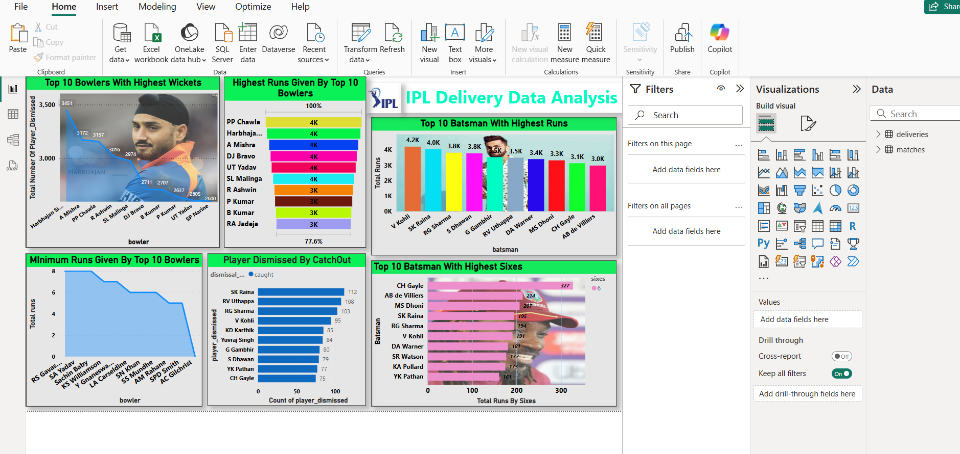

This comprehensive dashboard provides an overview of top bowler and batsman performances. It includes visuals for top 10 bowlers with highest wickets and minimum runs given, top 10 batsmen with highest runs and sixes, and player dismissed by catchout. This allows for quick identification of key performers and common dismissal methods, offering insights into individual strengths and weaknesses in different aspects of the game.

#### 8.2: Player Dismissal Analysis (Bowled, Run Out, LBW)

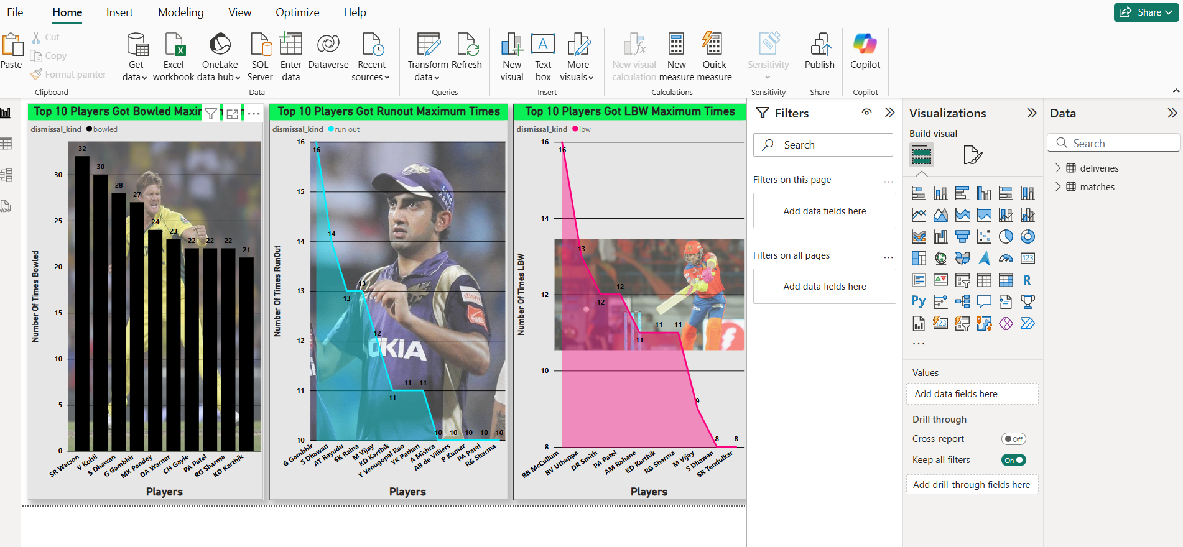

#### This set of charts details the players who have been dismissed maximum times by specific methods: bowled, run out, and LBW. By analyzing these visuals, one can identify batsmen who are more susceptible to certain types of dismissals, which can inform bowling strategies for opposing teams. For example, a player frequently bowled might have a weakness against fast, straight deliveries.

#### 8.3: Fielding and Bowling Error Analysis

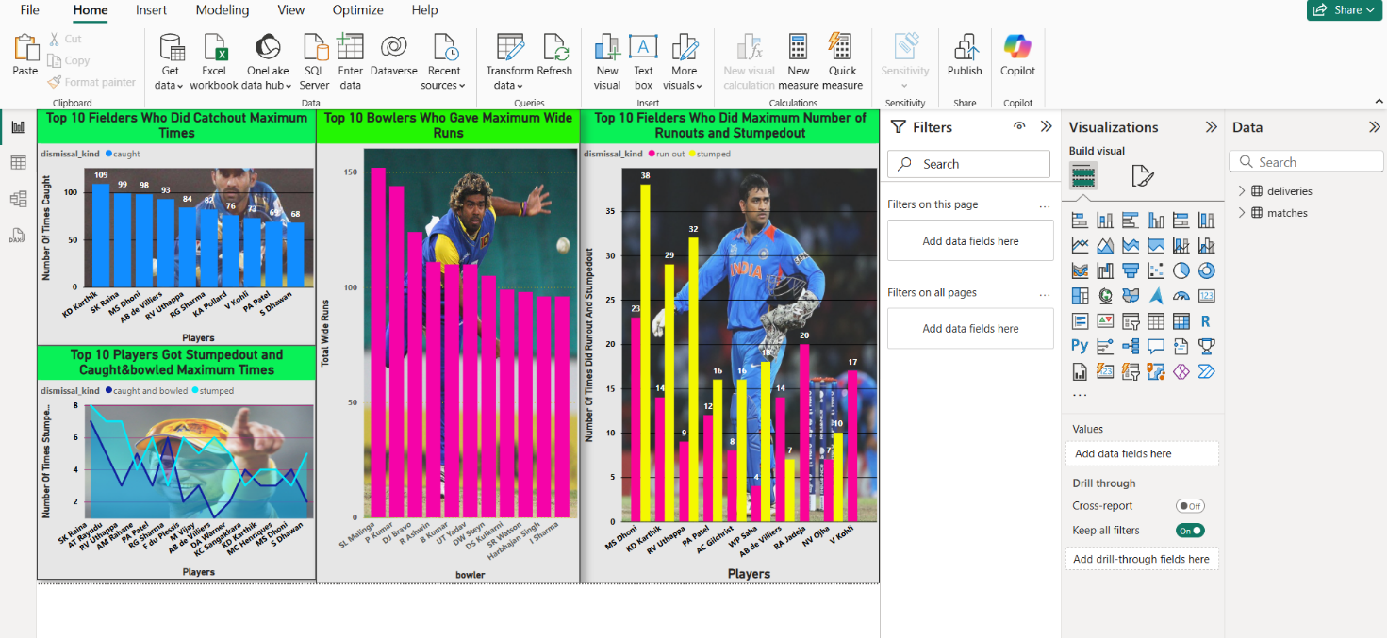

#### This dashboard focuses on fielding and bowling errors, specifically showing top 10 fielders with maximum catchouts, top 10 bowlers who gave maximum wide runs, and players with the maximum number of run-outs and stumpings. This provides insights into both strong fielders and bowlers who might be prone to giving away extra runs, as well as those who are most effective at getting run-outs and stumpings.

#### 8.4: Match Outcomes and Player of the Match Analysis

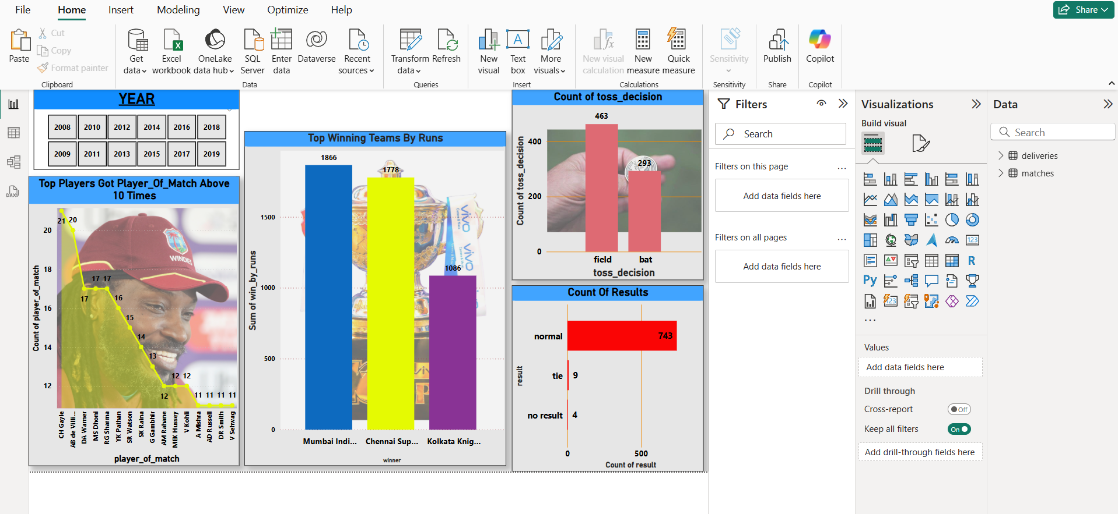This visualization set includes the distribution of matches won by runs and wickets, the count of toss decisions (fielding vs. batting), and the overall match results (normal, tie, no result). It also highlights players who have won the "Player of the Match" award more than 10 times. This helps in understanding the general trend of match outcomes, the impact of toss decisions, and recognizing consistent top performers.

#### 8.5: Venue and Team Performance Analysis

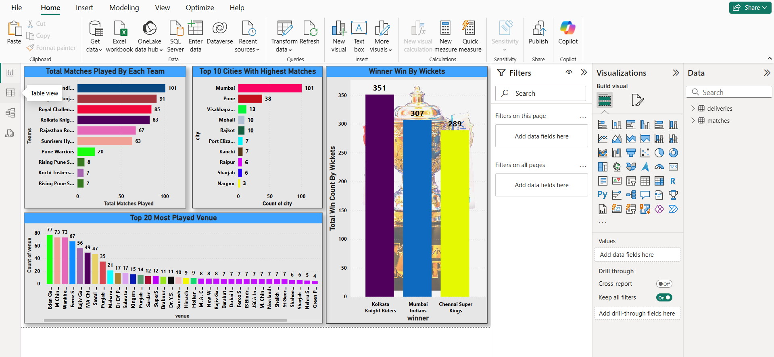

This visual provides an overview of match distribution across different teams and venues. It shows the total matches played by each team, top 10 cities with the highest number of matches, top 20 most played venues, and the total win count by wickets for the top winning teams. This offers insights into team activity, popular match locations, and which teams are dominant when winning by wickets, which typically indicates strong chasing capabilities.

### 8.5 Report Design and User Experience

The Power BI report was designed with user experience in mind. Pages were organized logically, and navigation was made intuitive. The use of consistent color schemes, fonts, and layouts ensured a professional and cohesive look. Tooltips were customized to provide additional details on hover, enhancing the interactivity and informative nature of the visuals. The goal was to create a self-service analytics environment where users could easily gain insights without needing deep technical knowledge.

**Dashboard and Key Insights**

This section consolidates the various visualizations developed in Power BI into a cohesive and interactive dashboard. The primary goal of this dashboard is to provide a comprehensive, at-a-glance view of critical IPL performance metrics, enabling stakeholders to quickly grasp the key findings and trends identified during the analysis. Beyond mere presentation, this section also highlights the overarching insights derived from the entire data analysis and visualization process, emphasizing their practical implications.

### 9.1 Dashboard Design and Layout

The Power BI dashboard was meticulously designed to ensure clarity, navigability, and impact. It integrates the most pertinent visualizations from Section 8, organizing them logically to tell a compelling story about IPL performance. The layout prioritizes ease of use, with key performance indicators (KPIs) prominently displayed and interactive elements (like slicers for seasons, teams, and players) readily accessible. This design allows users to drill down into specific areas of interest and explore the data dynamically without requiring extensive guidance.

* Logical Grouping: Related visuals (e.g., batting statistics, bowling metrics, team performance) are grouped together to facilitate intuitive data exploration.
* Interactivity: Slicers and filters are strategically placed to enable users to customize their view, focusing on specific seasons, teams, or players, thus providing a personalized analytical experience.
* Visual Hierarchy: Important metrics and overarching trends are highlighted through larger visuals or distinct card elements, guiding the user's attention to the most crucial information.
* Branding and Aesthetics: A consistent visual theme, including color palettes and fonts, was maintained to ensure a professional and cohesive appearance, aligning with the project's overall presentation standards.

### 9.2 Key Insights from the Dashboard

The integrated dashboard allows for the synthesis of individual findings into broader, more impactful insights. Based on the visualizations presented, several key observations and patterns emerged:

* Dominance of Established Teams: The analysis clearly shows that historically successful franchises like Mumbai Indians and Chennai Super Kings have consistently demonstrated superior performance, both in terms of overall wins and consistent player contributions. This suggests effective team management, consistent player retention, and strong strategic planning over multiple seasons.
* Impact of All-Rounders and Consistent Performers: The dashboard highlights players who frequently appear in top lists for both batting (runs, sixes) and bowling (wickets, economy). Such all-rounders and consistently high-performing specialists are invaluable to team success, often influencing match outcomes significantly. The "Player of the Match" analysis further reinforces the importance of these impactful individual performances.
* Bowling Strategies and Dismissal Patterns: The detailed breakdown of dismissal types provides insights into effective bowling strategies. For example, the prevalence of 'caught' dismissals underscores the importance of fielding, while analysis of 'bowled' or 'LBW' dismissals can point to specific technical weaknesses in batsmen.
* Venue and Toss Preferences: The dashboard reveals trends related to specific venues and the impact of toss decisions. Some venues might consistently favor chasing teams due to pitch conditions or dew factors, while others might offer an advantage to teams batting first. This information is crucial for strategic decision-making during matches.
* Evolution of Game Play: By using the season slicer, one can observe macro trends, such as changes in average scores over the years, shifts in the balance between bat and ball, or the increasing emphasis on power hitting.

### 9.3 Decision-Making Support for Stakeholders

The Power BI dashboard serves as a vital tool for various stakeholders, providing actionable insights that can influence strategic decisions:

* Team Management and Coaches: Can use the dashboard to analyze player performance, identify areas for improvement, evaluate potential recruits, and devise game strategies tailored to specific opponents or venues.
* Franchise Owners: Can leverage insights into team and player performance for auction strategies, brand building, and understanding return on investment for player acquisitions.
* Broadcasters and Media Analysts: Can utilize the data to create more engaging commentary, pre-match analyses, and post-match reviews, enriching the viewer experience.
* Cricket Enthusiasts and Analysts: Can explore the data to deepen their understanding of the game, make informed predictions, and engage in more insightful discussions.

The interactive nature of the dashboard ensures that these insights are not static but can be explored and customized to address specific questions, making it a powerful resource for data-driven decision-making in the world of IPL cricket.

**Code Snippets**

This section presents key code snippets from the IPL data analysis project, primarily derived from the Jupyter Notebook used for data collection, cleaning, preprocessing, and exploratory data analysis (EDA). These snippets illustrate the core functionalities and methodologies employed throughout the project, showcasing the practical application of Python libraries like Pandas, Matplotlib, and Seaborn.

### 10.1 Importing Libraries and Data Loading

The initial steps of any data analysis project involve importing necessary libraries and loading the datasets. The following snippet demonstrates the standard imports and how the matches.csv and deliveries.csv files were loaded into Pandas DataFrames.

import numpy as np

import pandas as pd

import matplotlib.pyplot as plt

import seaborn as sns

import plotly.express as pe

import warnings

warnings.filterwarnings(action='ignore')

pd.set_option('display.max_columns', None)

pd.set_option('display.max_rows', None)

# Loading the datasets

df_matches = pd.read_csv('matches.csv')

df_deliveries = pd.read_csv('deliveries.csv')

### 10.2 Data Cleaning and Preprocessing Example

Data cleaning and preprocessing are crucial steps to ensure data quality. This example shows a snippet of how missing values might have been handled or how a new feature, like 'win_by_wickets_or_runs', could be engineered to simplify analysis of match outcomes.

# Example: Handling missing values (hypothetical, based on common practice)

# if 'city' column had missing values and 'venue' could be used to fill them

# df_matches['city'].fillna(df_matches['venue'].apply(lambda x: x.split(',')[0]), inplace=True)

# Example: Renaming columns for consistency or clarity

# df_matches.rename(columns={'old_column_name': 'new_column_name'}, inplace=True)

# Example: Creating a new column for win margin type

# This could be used for analysis in Power BI

df_matches['win_by_wickets_or_runs'] = np.where(df_matches['win_by_runs'] > 0, 'win_by_runs', 'win_by_wickets')

# Displaying basic info after preprocessing

# print(df_matches.info())

# print(df_deliveries.head())

### 10.3 Exploratory Data Analysis (EDA) Snippets

EDA involves analyzing and visualizing data to discover patterns, trends, and relationships. Here are examples of code used for common EDA tasks:

#### 10.3.1 Most Man of the Match Awards

This snippet identifies players with the most 'Player of the Match' awards.

# Get the top 10 players with most 'player_of_match' awards

player_of_match_counts = df_matches['player_of_match'].value_counts().head(10)

print(player_of_match_counts)

# Visualization (example using seaborn, similar to Power BI visual)

plt.figure(figsize=(10, 6))

sns.barplot(x=player_of_match_counts.index, y=player_of_match_counts.values)

plt.title('Top 10 Players with Most Man of the Match Awards')

plt.xlabel('Player')

plt.ylabel('Number of Awards')

plt.xticks(rotation=45, ha='right')

plt.tight_layout()

plt.show()

#### 10.3.2 Top Run Scorers

This code calculates and displays the top 10 batsmen based on total runs scored.

# Calculate total runs scored by each batsman

total_runs_batsman = df_deliveries.groupby('batsman')['batsman_runs'].sum().sort_values(ascending=False).head(10)

print(total_runs_batsman)

# Visualization

plt.figure(figsize=(12, 7))

sns.barplot(x=total_runs_batsman.index, y=total_runs_batsman.values, palette='viridis')

plt.title('Top 10 Run Scorers in IPL')

plt.xlabel('Batsman')

plt.ylabel('Total Runs')

plt.xticks(rotation=45, ha='right')

plt.tight_layout()

plt.show()

#### 10.3.3 Top Wicket Takers

This snippet identifies the top 10 bowlers based on the number of wickets taken. Note that 'dismissal_kind' needs to be filtered to exclude run-outs, retirements, etc., to accurately count wickets for bowlers.

# Filter for actual dismissals (excluding run out, retired hurt etc.)

dismissal_types = ['caught', 'bowled', 'lbw', 'stumped', 'caught and bowled', 'hit wicket']

wickets = df_deliveries[df_deliveries['dismissal_kind'].isin(dismissal_types)]

# Group by bowler to count wickets

top_wicket_takers = wickets.groupby('bowler')['dismissal_kind'].count().sort_values(ascending=False).head(10)

print(top_wicket_takers)

# Visualization

plt.figure(figsize=(12, 7))

sns.barplot(x=top_wicket_takers.index, y=top_wicket_takers.values, palette='plasma')

plt.title('Top 10 Wicket Takers in IPL')

plt.xlabel('Bowler')

plt.ylabel('Total Wickets')

plt.xticks(rotation=45, ha='right')

plt.tight_layout()

plt.show()

#### 10.3.4 Dismissal Kind Analysis

This code analyzes the frequency of different dismissal types.

# Count the occurrences of each dismissal kind

dismissal_kind_counts = df_deliveries['dismissal_kind'].value_counts()

print(dismissal_kind_counts)

# Visualization (e.g., using a pie chart or bar chart)

plt.figure(figsize=(10, 8))

plt.pie(dismissal_kind_counts, labels=dismissal_kind_counts.index, autopct='%1.1f%%', startangle=140, pctdistance=0.85)

plt.title('Distribution of Dismissal Kinds')

plt.axis('equal') # Equal aspect ratio ensures that pie is drawn as a circle.

plt.tight_layout()

plt.show()

### 10.4 Joining DataFrames for Combined Analysis

For analyses that require information from both df_matches and df_deliveries, a merge operation is performed.

# Merging both dataframes on 'match_id' for comprehensive analysis

combined_df = pd.merge(df_matches, df_deliveries, on='match_id', how='inner')

# Example: Analyzing runs per over across seasons

# runs_per_over_season = combined_df.groupby(['season', 'over'])['total_runs'].sum().unstack()

# print(runs_per_over_season.head())

These snippets represent a fraction of the Python code utilized in the project. They demonstrate the fundamental operations of data handling, transformation, and initial visualization that lay the groundwork for the more advanced interactive dashboards in Power BI.

**Web-Based Match Prediction Module**

To make the IPL data analysis project more interactive, a web-based match prediction module was added as an extension to the main analysis and dashboard. This tool allows users to select two IPL teams, the toss winner, and the toss decision (bat or field), and then gives predictions for the match based on team strength and past performance. The prediction includes match winner, top scorer, best bowler, player of the match, expected score range, and number of sixes or wickets. This prediction tool is created using HTML, CSS, and JavaScript, and is fully functional within a browser. It does not use a server or machine learning model in the backend, but the logic used is based on previous analysis and team performance. Each team is mapped with three main players who are known for their batting, bowling, and all-rounder roles. Based on the selected inputs, the tool displays results using predefined rules and conditional logic. This gives a fast, easy-to-use, and data-supported prediction experience.

In addition, the Power BI dashboard that was created using Python-cleaned IPL data is also embedded into the same page. The dashboard shows historical team performance, toss impact, player statistics, and match outcomes in visual form. This helps users compare predictions with actual team history and trends. Although the prediction logic is currently rule-based and works on the front-end, it can be enhanced in the future using machine learning techniques such as logistic regression or decision trees. Also, live match data from APIs can be used to make real-time predictions more accurate. The entire module can be improved by adding a Python backend using Flask or Streamlit for deeper insights. Overall, this module combines data analysis, dashboard visuals, and prediction logic into a single user-friendly system. It adds practical value to the project by showing how analytics and real-world applications can be connected in a single solution.

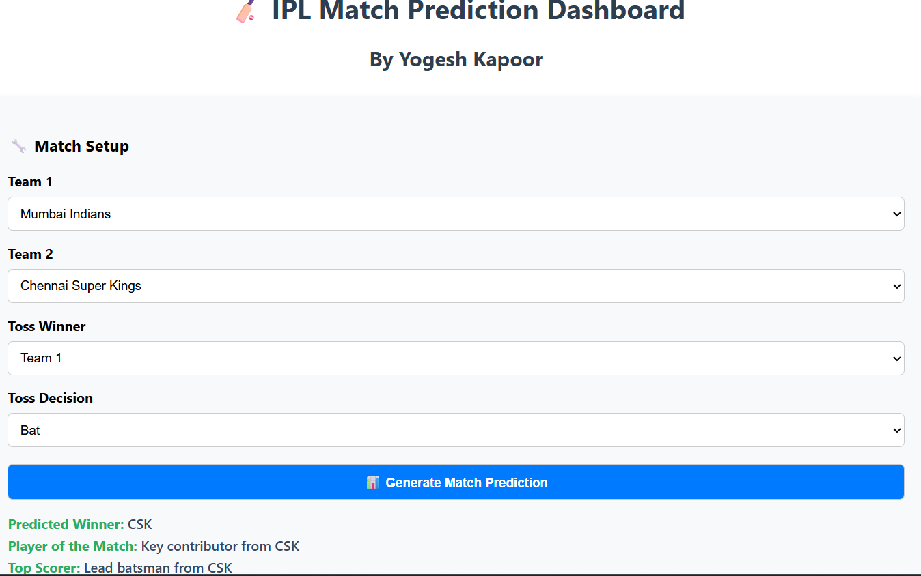

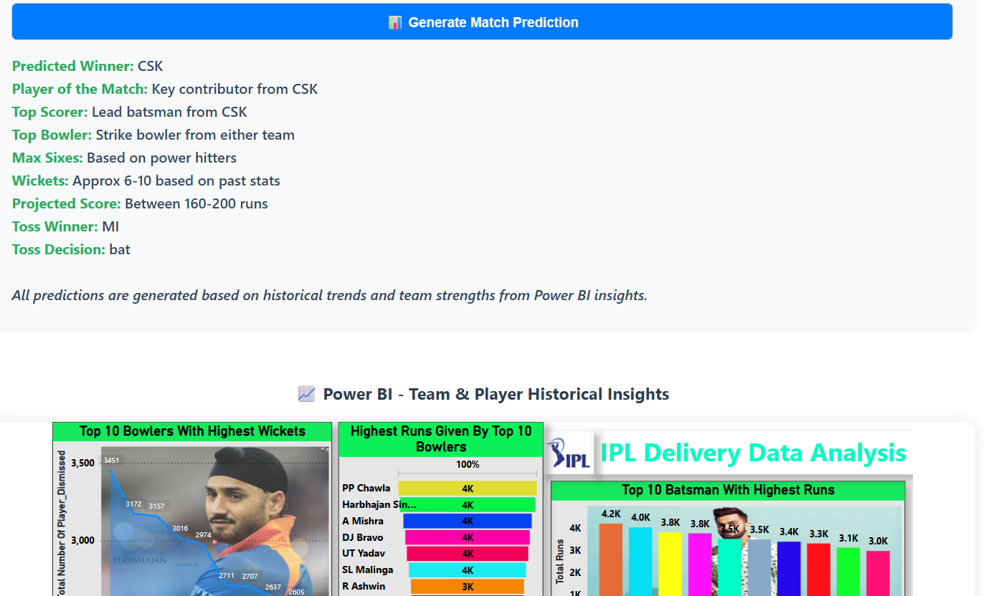

**Conclusion**

This project focused on the comprehensive analysis of Indian Premier League (IPL) cricket data, leveraging both match-level and ball-by-ball datasets spanning multiple seasons. Through meticulous data collection, cleaning, and preprocessing, the project ensured high data quality and consistency, which was crucial for accurate analysis.

By utilizing Power BI for data visualization, the project successfully transformed large volumes of raw data into meaningful visual insights. The dashboards created provide an interactive platform to explore various dimensions of IPL matches, such as team performance trends, player statistics, match results, and detailed delivery-level events.

The analysis highlighted significant findings, including the dominance of certain teams over the years, key player contributions that influenced match outcomes, and the strategic impact of toss decisions. Additionally, the delivery-level visualization offered granular insights into scoring patterns, bowling effectiveness, and wicket-taking scenarios.

This work demonstrates the importance of data-driven decision making in sports, especially cricket, where nuanced insights can enhance team strategies and player development. The interactive dashboards developed can be used by analysts, coaches, and fans alike to better understand the dynamics of the game.

Moreover, this project lays the groundwork for more advanced applications such as predictive analytics and real-time game monitoring. Future enhancements could include integrating machine learning models to predict match outcomes, player performance forecasting, and automated anomaly detection.

In conclusion, the project not only showcases technical skills in data scraping, processing, and visualization but also contributes valuable insights into IPL cricket, reaffirming the transformative role of data science in sports analytics.

**References**

1. **ESPN Cricinfo.** IPL Match Data and Statistics. Retrieved from https://www.espncricinfo.com/series/ipl-2023-1345038/match-results (Accessed: June 2025).
2. **Python Software Foundation.** Python Programming Language. Available at: <https://www.python.org/> (Accessed: June 2025).
3. **Beautiful Soup Documentation.** Beautiful Soup: Python library for parsing HTML and XML documents. Available at: https://www.crummy.com/software/BeautifulSoup/ (Accessed: June 2025).
4. **Pandas Documentation.** Python Data Analysis Library. Available at: https://pandas.pydata.org/ (Accessed: June 2025).
5. **Microsoft Power BI.** Business Analytics Service by Microsoft. Available at: <https://powerbi.microsoft.com/> (Accessed: June 2025).
6. **Kaggle IPL Dataset.** IPL Ball-by-Ball Data. Available at: https://www.kaggle.com/datasets/ramjidoolla/ipl-ball-by-ball-dataset (Accessed: June 2025).

**Appendix**

## Appendix A: Description of IPL Match-Level Data Columns

| Column Name | Description |
| --- | --- |
| id | Unique identifier for each match |
| city | City where the match was played |
| date | Date of the match (YYYY-MM-DD) |
| player_of_match | Name of the player awarded "Player of the Match" |
| venue | Venue or stadium name |
| neutral_venue | Indicator if the venue was neutral (0 = No, 1 = Yes) |
| team1, team2 | Names of the two competing teams |
| toss_winner | Team which won the toss |
| toss_decision | Decision taken by toss winner (bat/field) |
| winner | Team which won the match |
| result | Result type (normal, tie, no result) |
| result_margin | Margin by which the match was won (runs/wickets) |
| eliminator | Indicator if match was an eliminator (0 = No, 1 = Yes) |
| method | Method of result (e.g., D/L method) |
| umpire1, umpire2 | Names of the two umpires |

## Appendix B: Description of Ball-by-Ball Data Columns

| Column Name | Description |
| --- | --- |
| id | Unique match identifier |
| inning | Innings number (1 or 2) |
| over | Over number |
| ball | Ball number within the over |
| batsman | Name of the batsman on strike |
| non_striker | Name of the non-striker batsman |
| bowler | Name of the bowler delivering the ball |
| batsman_runs | Runs scored by the batsman on this delivery |
| extra_runs | Runs scored as extras (wide, no-ball, leg-bye, bye) |
| total_runs | Total runs scored on the delivery |
| non_boundary | Indicator if runs were non-boundary (0 = boundary, 1 = non-boundary) |
| is_wicket | Indicator if wicket fell on this ball (0 = No, 1 = Yes) |
| dismissal_kind | Type of dismissal (caught, bowled, lbw, etc.) |
| player_dismissed | Name of the player dismissed |
| fielder | Name of fielder involved in dismissal (if any) |
| extras_type | Type of extra run (wide, no-ball, bye, leg-bye) |
| batting_team | Batting team name |
| bowling_team | Bowling team name |

## Appendix C: Sample Python Code Snippet

import pandas as pd

# Load ball-by-ball dataset

df = pd.read_csv('ipl_ball_by_ball.csv')

# Drop duplicate rows and fill missing dismissal info

df.drop_duplicates(inplace=True)

df.fillna({'fielder': 'None', 'dismissal_kind': 'Not Out'}, inplace=True)

# Add a total runs column

df['total_runs'] = df['batsman_runs'] + df['extra_runs']

print(df.head())

## Appendix D: Additional Visuals and Charts

## Who got out by caught maximum time?

## 

# Player Who got out by Runout maximum time

# 

# Player Who got out by LBW maximum time

# 

# Top 10 Bowlers Who Gave Maximum Number Of Runs

# 

# Top 10 Fielders Who Did Maximum Number of Runouts

# 